Subject Area: 2D Design Grade Level: High School
Formative or Performance Task: Students will create a contour line portrait.
A.Reaching Consensus about Proficiency Read the assessment prompt and/or rubric and explain:
- What are the students expected to do?
Students are expected to create an accurate and expressive contour line portrait of a person.
- Which standards (CCSS or content standards) or curriculum expectations are being assessed?
Observe and Learn to Comprehend and Invent and Discover to Create. Students are being asked to develop observational skills that will enable them to create a two- dimensional contour portrait of a person.
- What do you consider to be a proficient response on this assessment?
Students are assessed on five features of their work:
Composition: Student uses the whole piece of paper for their portrait
Line quality: Student uses a variety of line thickness and values, shows use of continuous line, and no shading.
Proportion: Student draws what they see and not something made-up. Features are drawn in relationship to each other.
Craftsmanship: Student’s work is neat, and paper is in good condition and important details are included
Effort/attitude: Student stayed focused during the process of creating the portrait and contributed to a productive classroom environment.
- Exactly what do students need to say or write for you to consider their work proficient?
To consider student’s work proficient, I should be able to tell who the portrait is of and they should meet the above basic requirements.
- Did the assessment give students a good opportunity to demonstrate what they know?
Students participated initially in a pre-instructional contour portrait where they were asked to draw a portrait without any teacher guidance. This was effective in gauging the student’s skill level and to instruct them accordingly to enable them to produce more proficient drawings. The final post-instructional drawing gave students an opportunity to show what they had learned and this was evident in many of their drawings.
B. Diagnosing Student Strengths and Needs After reaching consensus, read student work and without scoring, do a “quick sort” of students’ work by the general degree of the objectives met, partially met, not met. You may need a “not sure” pile. After sorting, any papers in the “not sure” pile should be matched with the typical papers in one of the other existing piles. Student names should be recorded in the columns in order to monitor progress over time.

High (Objectives Met) | Expected (Objectives Partially Met) | Low (Objectives not met)
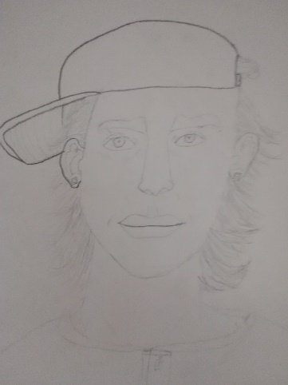  Tobias | 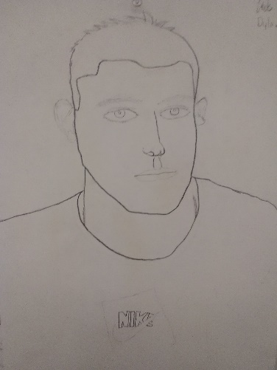  Wade | 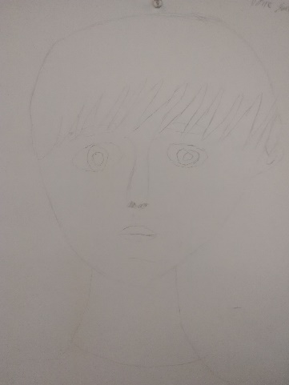  Dayne
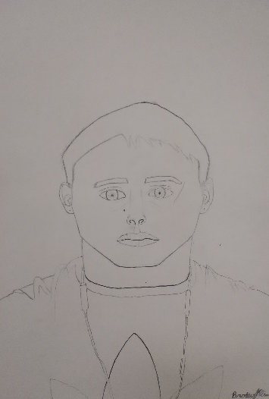  Brody | 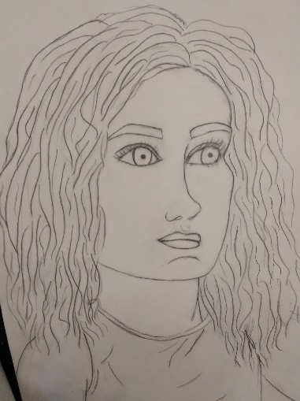  Lauren | 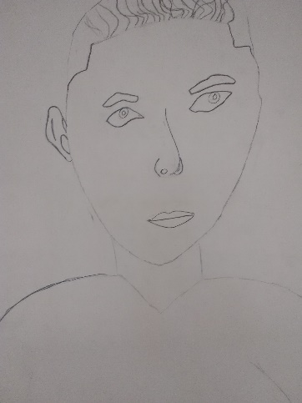  Hunter
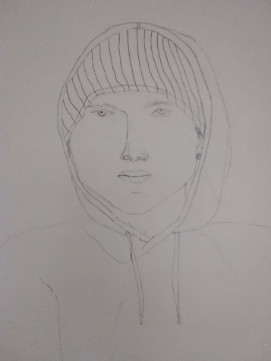  Trenton | 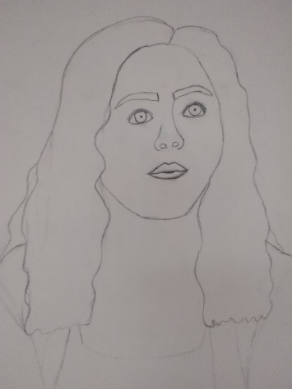  Lindsay | 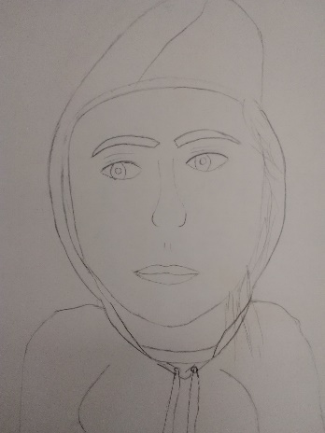  Jadyn
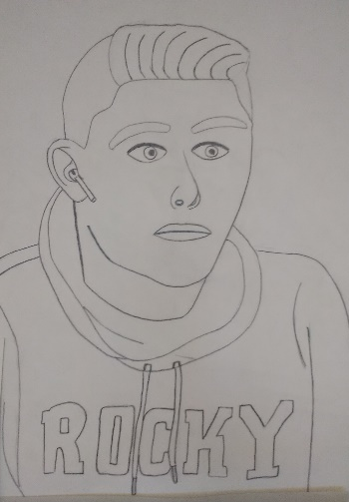  Nick | 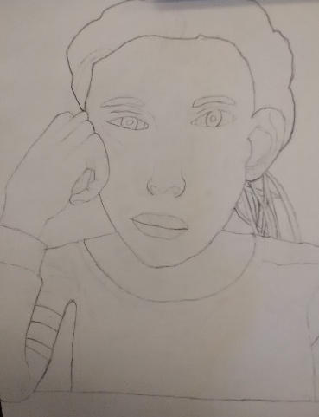  Caleb
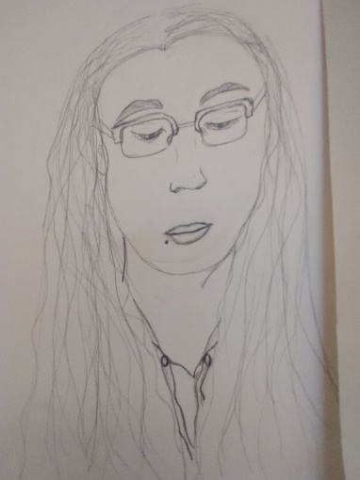
Sofia
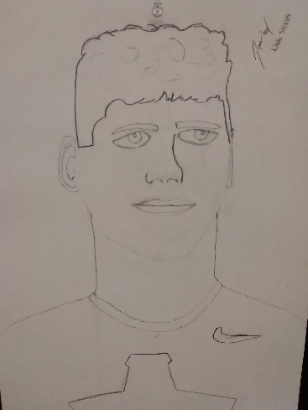
Dillon
% of sample: 31% | % of sample: 46% | % of sample: 23%

C. Choose a few samples to review from each level (low, expected, high) and discuss and identify the prerequisite knowledge that students demonstrated that they knew.
High (Objectives Met) | Expected (Objectives partially met) | Low (Objectives not met)
Trenton accurately rendered his portrait using only contour line. He portrayed his subject in correct proportion, used a majority of the page, and used a line variation to denote depth. | Caleb’s portrait captured the essence of his sitter which is one of the main objectives of portraiture. He also challenged himself to draw her hand accurately and was close to achieving accurate proportions. | I can tell which student Dayne was drawing, but the proportions are inaccurate, and the line variation does not create depth.
Brody’s portrait can easily be identified as Tobias and although the head is a bit small, the proportions are overall accurate. Line variation is used to denote depth and the artist has used most of the paper. The student also was focused and engaged in the assignment which showed in the improvement from his pre-instructional drawing. | Dillon showed huge improvement from his pre-instructional drawing. His portrait is identifiable as the sitter and his line variation creates depth, but the features are slightly disproportionate to each other and line variation is somewhat arbitrary. | Hunter was close to capturing the essence of the subject sitting for him, but the proportions are inaccurate and the lines lack variation. He seems to have drawn what he thinks he sees instead of what he actually sees in front of him.
Nick’s drawing captures the essence of the person he is drawing, the proportions are accurately placed on the face and drawn from life, he has included details that add interest to the composition and has used the entire page. | Lindsay’s composition is pleasing, but it is difficult to identify her subject based on her features. The proportions are accurately placed, but more detail could be included to add interest to the composition and capture the essence of her sitter. | I can tell who Jadyn is drawing in the portrait, but the head is too large in comparison to the body and the features are too large in comparison to the face.

D. Using the reviewed samples from each level, discuss and identify the misconceptions, wrong information, and what students did not demonstrate that was expected.

High (Objectives Met) | Expected (Objectives partially met) | Low (Objectives not met)
Could use a bit more line variation and Mabrion’s face is a bit more elongated. The essence is captured but accuracy could be improved. | The proportion of the features is a bit off and could benefit from more line variation. | In general, the portrait is out of proportion and the marks are too light to read. Although the artist captured the general essence of the sitter it seems he was drawing what he thought a young man looks like, not what the young man actually looked like.
Although the proportions are accurate to the drawing, the sitter’s head is a bit more elongated. Brody drew the features accurately in comparison to the head he drew, but the head is a bit inaccurate. | Dillon’s use of line variation is a bit arbitrary and doesn’t denote depth. The subject’s proportions are a bit inaccurate even though the essence of the sitter is evident. | Hunter has drawn what he thinks a human looks like. He has given his figure human features, but they are not based on the actual features of he person sitting for the portrait which is why it is hard to identify this person.
Nick’s portrait is accurate, but it is hard for me to tell exactly which student he is drawing. The features, while proportional, may not completely depict the actual sitter’s features. | Lindsay’s portrait could use a bit more detail within the outlines of the figure. | Jadyn’s portrait is rendered with little detail and inaccurate proportions. She seems to be drawing what she thinks a human girl looks like instead of Sophia.

P a g e | 8
Student Work Analysis Protocol (continued)

E. Identifying Instructional Next Steps After diagnosing what the student knows and still needs to learn, discuss as a team the learning needs for the students in each level considering the following questions:

Based on the team’s diagnosis of the student’s performance:

▪ What patterns or trends are noted for the whole class?
As a class the students are beginning to understand that rendering an accurate and expressive portrait involves drawing what you actually see and not what you think you see. The technical activities such as blind contours and upside-down drawings are designed to break down the wall in a person’s brain that filters the information they receive visually before they can draw it and gives the thing they’re drawing a name. When this barrier is broken down, artists are more capable of drawing the exact forms they see in front of them rather than what they think something, say a face, is “supposed” to look like. All of the students are showing improvement in accuracy and capturing the essence of their subject, but some still struggle with isolating what they are drawing enough to understand it compositionally. That is, they are drawing a stereotypical pair of lips rather than the shapes and lines that make up the specific individual’s lips they are looking at.

▪ What instructional strategies will be beneficial for the whole class?
Continuing to introduce activities that improve technical accuracy of the student’s drawings will only further their ability to render their subject as it is and not as they think it is. The next activity will be the gridded self portrait which will enable students to isolate a small part of a face into one square. When they can focus on accurately depicting the shapes and lines within that square of the grid, they will see their brain will practice further breaking down the barrier between what they see and what they draw. No matter their current skill level, gridded portraits act as a tool to encourage accuracy.
▪ Based on the team’s diagnosis of student responses at the high, expected, and low levels, what instructional strategies will students at each level benefit from?

High (Objectives Met) | Expected (Objectives partially met) | Low (Objectives not met)
Students that have accurately rendered expressive and identifiable portraits will benefit from the gridded self portrait activity. Most of them have mastered rendering a portrait accurately and with depth using only contour line and have expressed interest in using value. Using the grid tool students at this level will be able to see where to place different values accurately to create dimension in their drawings. The grid will also help work out the small kinks in line accuracy and feature placement. | Many of these students captured the essence of their sitter but were a bit inaccurate in the rendering of their portraits. These students will benefit from basic technical skill packets that introduce them to commonalities between complicated features such as the nose and mouth. Although we don’t want them to draw all features in the same way, these practice packets will help them see the intricacies of the shapes that make up human features and recognize them in the subjects of their gridded portraits. | Students might benefit from starting instruction each day with another simple drawing activity that encourages the artist to let go of attachment to the name of the object they are drawing. Some of the activities they are familiar with such as the blind contour encourage students to not even look at the paper while they are drawing and instead attempt to draw exactly what they see in front of them in one continuous line. These students might also benefit from the feature packets because they will give them a two-dimensional rendering of the feature to practice with rather than having to translate the three dimensional figure sitting in front of them.

