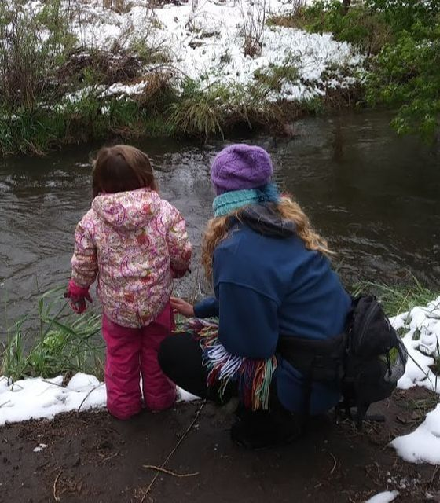 |  | EDUCATION
Colorado State University, Fort Collins, CO.
Anticipated Graduation Date: December 2019

Bachelor of Fine Arts with a concentration in painting and art education.
- Bookstaber Scholarship for Art Education.
- Evalyn Prouty Hickman Scholarship.
- Dean’s List.
- CSU Cumulative GPA: 3.840

Katie Lynn walker  Professional Goals  - To facilitate students in exploring their relationship to themselves and the world around them through artistic expression.  - To work towards providing equal access to quality education for all students regardless of socioeconomic status.  - To create a classroom environment where students feel empowered and capable of creating tangible works of art based on their ideas and conceptions.  CONTACT  PHONE:  970-889-1880  WEBSITE:  https://katielynnwalker.weebly.com/  EMAIL:  katie@rams.colostate.edu |  | WORK EXPERIENCE
Wild Roots Studio, Fort Collins, CO June 2016-currently employed
Nature guide and art instructor
- Designed and taught nature-based art projects for students ages 5-12. Our pedagogy involves facilitating students in developing a relationship with the environment through exploring nature as a subject and medium for works of art.
Phelan-Dubois Family, Fort Collins, CO.
June 2016-Currently employed
Nanny
- Provided meals, transportation, and supervision.
- Designed educational and imaginative adventures for two children ages 2 and 4 throughout the summer and school year.
A Way of Life- Nature Based Academy, Fort Collins, CO June 2016-August 2018
Pre School Teacher and Nature Guide
- Designed art curriculum for pre-school aged children based on Waldorf pedagogy.
- Guided and instructed students in basic survival as well as plant and animal identification.
Burlington Elementary School, Longmont, CO.
Jun. 2006-August 2008

Childcare Assistant
- After school and summer camp for kids K-12.
- Accountable for 40+ children with a staff of about 4-5 people.
- Organized day activities, meals, field trips, and lessons.
- Maintained an environment that promoted growth mentally and physically for children in the program.

