Standards Elements Evaluation
Quality Standard I: Teacher demonstrates knowledge of the content, central concepts, inquiry, appropriate evidence based instructional practices, and specialized characteristics of disciplines being taught.
Rationale: As an artist and educator I have acquired the knowledge of content, central concepts, and specialized characteristics of many mediums of art including the tools and techniques involved in fibers, printmaking, photography, pottery, two-dimensional design, three-dimensional design, and sculpture as well as the central concepts involved in the study of art including art history and the elements and principles of design.
Aligned Instruction: Using Understanding by Design Lesson plans I have incorporated the Colorado Visual Arts Standards into every lesson I have taught during student teaching. UBD involves planning lessons with the desired learning objectives as the focus and then designing activities that support these intended results. In this way instruction becomes aligned with the standards because they provide the purpose and skeleton for instruction.
Section of lesson plan for “Servin’ Up Social Justice” for high school pottery class:
Enduring Understanding (s):
Enduring Understandings show a relationship between two or more concepts; connected with an active verb. The best enduring understandings not only link two or more concepts; but demonstrate why this relationship is important. Like concepts, they are timeless, transferrable and universal.
- Artists use visual language to raise awareness and/or express opinions about important issues of social justice.
- Art can be a catalyst for difficult discussions about important social issues.
- Creating art about a specific issue can lead to a deeper understanding of that issue.
- Artists use research to inform the conceptual intent and visual appearance of their artwork.

Objectives/Outcomes/Learning Targets:
Objectives describe a learning experience with a condition → behavior (measurable) → criterion. Aligned to: Bloom’s – Standards – GLEs - Art learning and, when appropriate, Numeracy, Literacy and Technology. Should be written as: Objective. (Bloom’s: _____ - Standard: _____ - GLE: _____ -Art learning: _____ -Numeracy, Literacy, and/or Technology)
- After exploring personally relevant social issues through group discussion, students will conduct research which will inform the final design for their artwork and enable them to develop a deeper understanding of the difficulties facing our world society. (Understand/Evaluate_Observe and Learn to Comprehend_ Planning/Ideation_Literacy/Technology.)
- After conducting research on a personally relevant social issue, students will create artwork that raises awareness and catalyzes conversations about important social issues. (Analyzing/Understanding_Invent and Discover to Create_Language of Art/World of Art and Culture.)
- After exploring different techniques of creating surface design, students will use carving, stamping, textures, glazes and press molds to visually represent a current or historical social issue. (Creating/Applying_Invent and Discover to Create_Materials/Techniques/Tools.)
- While developing their final product, students will document their ideation, process, works in progress, and artist statement on an online portfolio. (Evaluating/Analyzing_Envision and Critique to Reflect_ Critical Reflection/Student Reflective Activity)
- After creating a work of art that visually represents an important social issue, students will create an artist statement that reflects on their developing perspectives on the issue and the communicative power of expressing those perspectives through art. (Analyzing/Evaluating_Relate and Connect to Transfer_Critical Reflection/Student Reflective Activity.)
Content Knowledge: Teaching for Artistic Behavior (TAB) requires extensive knowledge of the tools and techniques of many different studio mediums including fibers, printmaking, painting, drawing, and collage as well as knowledge of related art history and efficient methods for instructing students in independently working in these studios. While student teaching, I was required to conduct demonstrations of many different techniques at the high-school and elementary level. For some demos I assisted in creating demo videos for elementary students to learn complicated fibers techniques such as weaving. Below is a link to one such video:
Circle Weaving Demonstration Video
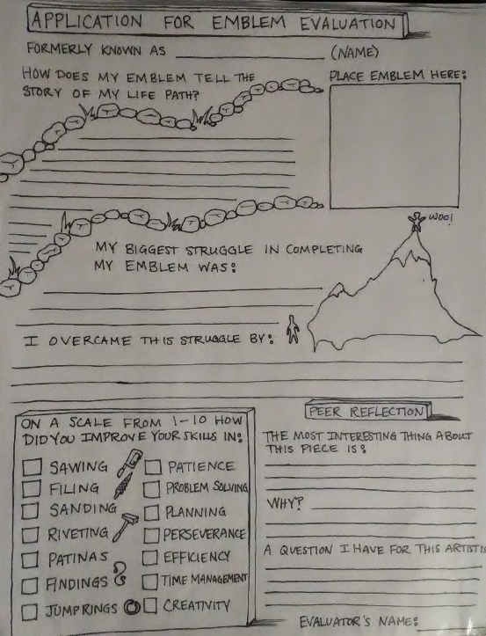
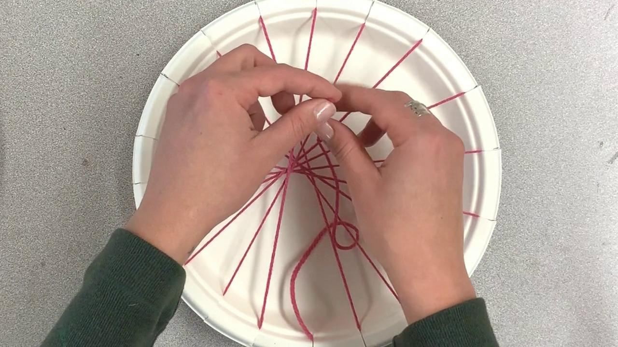Interconnected Lessons: While teaching high school jewelry it was important to scaffold lessons to allow for students to gain the necessary skills to complete the technical learning objectives of each new project. In this way the lessons naturally built on each other in technical content, instruction, and central concepts. For example, the first lesson was centered around learning the basic metalsmithing skills of sawing, filing, riveting, sanding, and finishing so students were asked to develop a piece of jewelry that showcased their “life path,” which was a line that represented the physical ups and downs of their life journey. The next lesson built on those skills adding the techniques of enameling with the final lesson involving soldering. While reflecting and assessing their work on the first project, students were asked to not only discuss concept, but talk about their improvements in their technical metalsmithing skills and reevaluated these skills each lesson. Below is a picture of the self-evaluation/reflection students used during their first project:
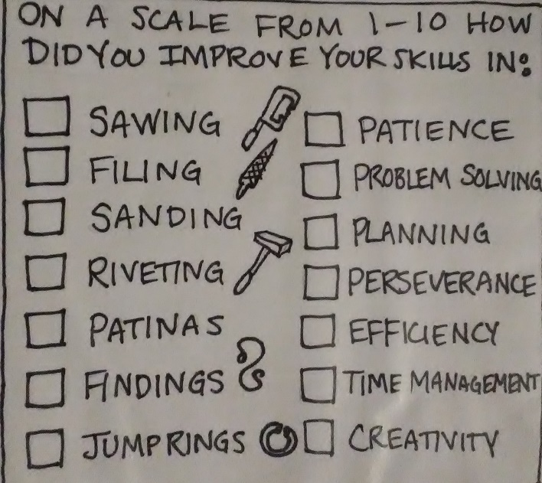

Quality Standard II: Teacher fosters a predictable learning environment characterized by acceptable student behavior and efficient use of time in which each student has a positive nurturing relationship with caring adults and peers.
Rationale: One of the most important aspects of being an educator is developing relationships with students and colleagues. Through authenticity and genuine engagement in my student’s success and well being I have found that I foster a positive and inclusive learning environment in my classroom. Through group discussion about acceptable behavior and expectations and consistent studio procedures I have helped develop a predictable and structured learning environment. Especially in my elementary experience, I saw the importance of developing a very dependable routine for students. I worked with a teacher who teaches for artistic behavior which enables students to work freely while adhering to the visual arts standards through structured reflection, conferences, student assessment, and setting of learning targets. The daily routine allowed for students to spend their time on what matters; making art.
Predictable, caring, and positive learning environment: I had the opportunity in my high school experience to begin teaching a new group of students from day one. Before jumping in to any content, I decided I wanted to get to know my students and their interests. To do so I developed a fun work sheet for students to fill out about their passions and interests. I also developed a lesson I used in all three of the classes I taught which centered around students choosing a meaningful quote, exchanging the quote anonymously with another student, then creating a work of art that visually expressed that quote. Facilitating this lesson and group refection enabled me to gauge my student’s interests, passions, and creative ability before beginning to plan content-centered lessons. Below is an example of one student’s work sheet about their personal interests:
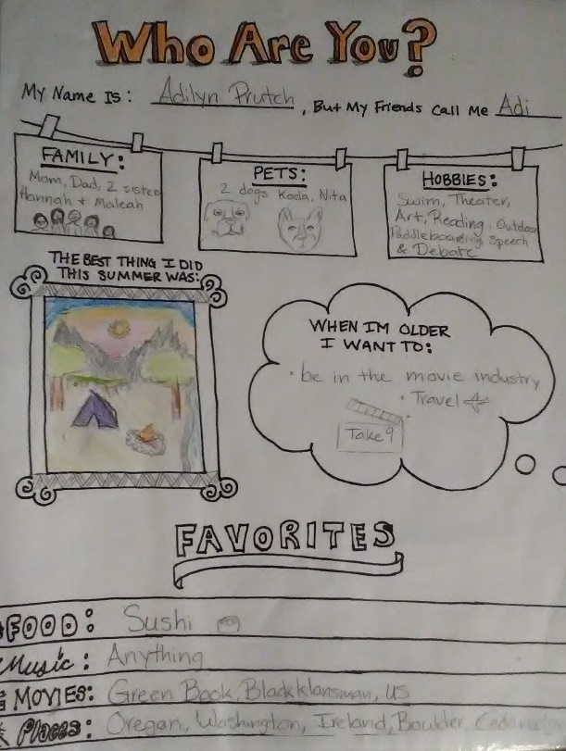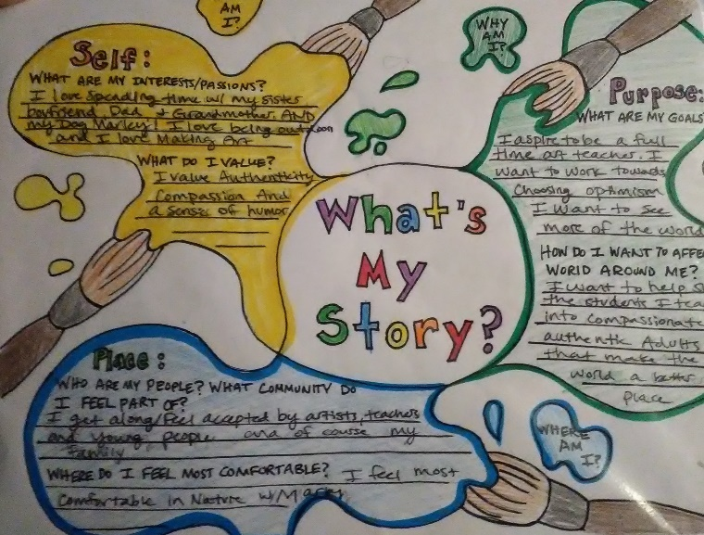
Commitment and Respect for Diversity: In my high school pottery class I was required to teach a lesson centered around the concept of social justice. When planning the lesson, I wanted to be thoughtful of the differing opinions and beliefs of a population of students who come from many different backgrounds, so I began by evaluating the idea of social justice rather than picking an issue I care about and asking the students to make art about it. Students were asked to evaluate their personal core values before the topic of social justice was even introduced, then brainstorm which of those values were violated by certain social justice issues such as racism, sexism, and violence. This resulted in an open discussion about the challenges that face our society and gave students a starting point to begin planning their social justice platters. In this way the lesson gave students the freedom and respect to discuss their ideas freely and develop works of art that comment on tough social issues.
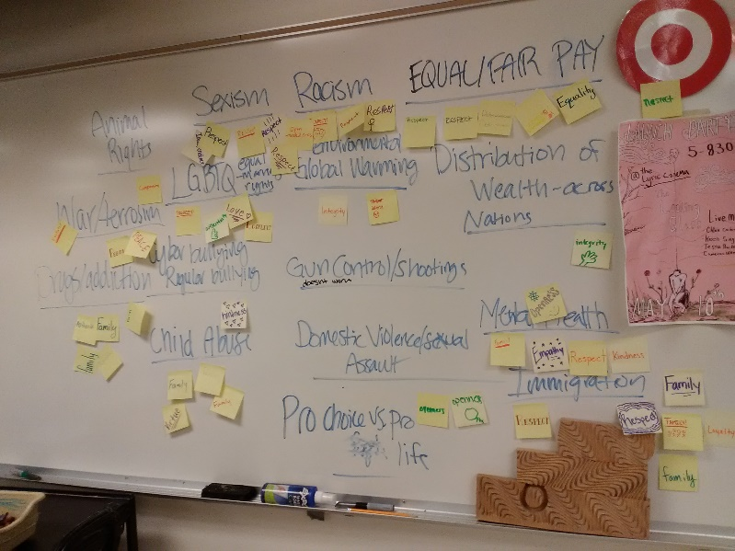
Efficient Use of Time: In my experience I have seen the extreme importance of time management to being an efficient educator. One of the most important aspects of teaching is to allow student artists to have the maximum amount of time to explore artistic concepts and techniques which is why I attempt to keep instruction as essential and quick as it can be. Especially with elementary students it is ideal to keep instruction short and to the point which is why I employ the “five-minute demo.” The goal here is to provide students with everything they need to know to reach the learning targets without bombarding them with information that is non-essential. Below is an example of the schedule I plan to use in my classroom one day. It involves a short five-minute demo followed by structured studio time, group reflection and discussion about student work. In this model, students have as much time as possible working in studios.
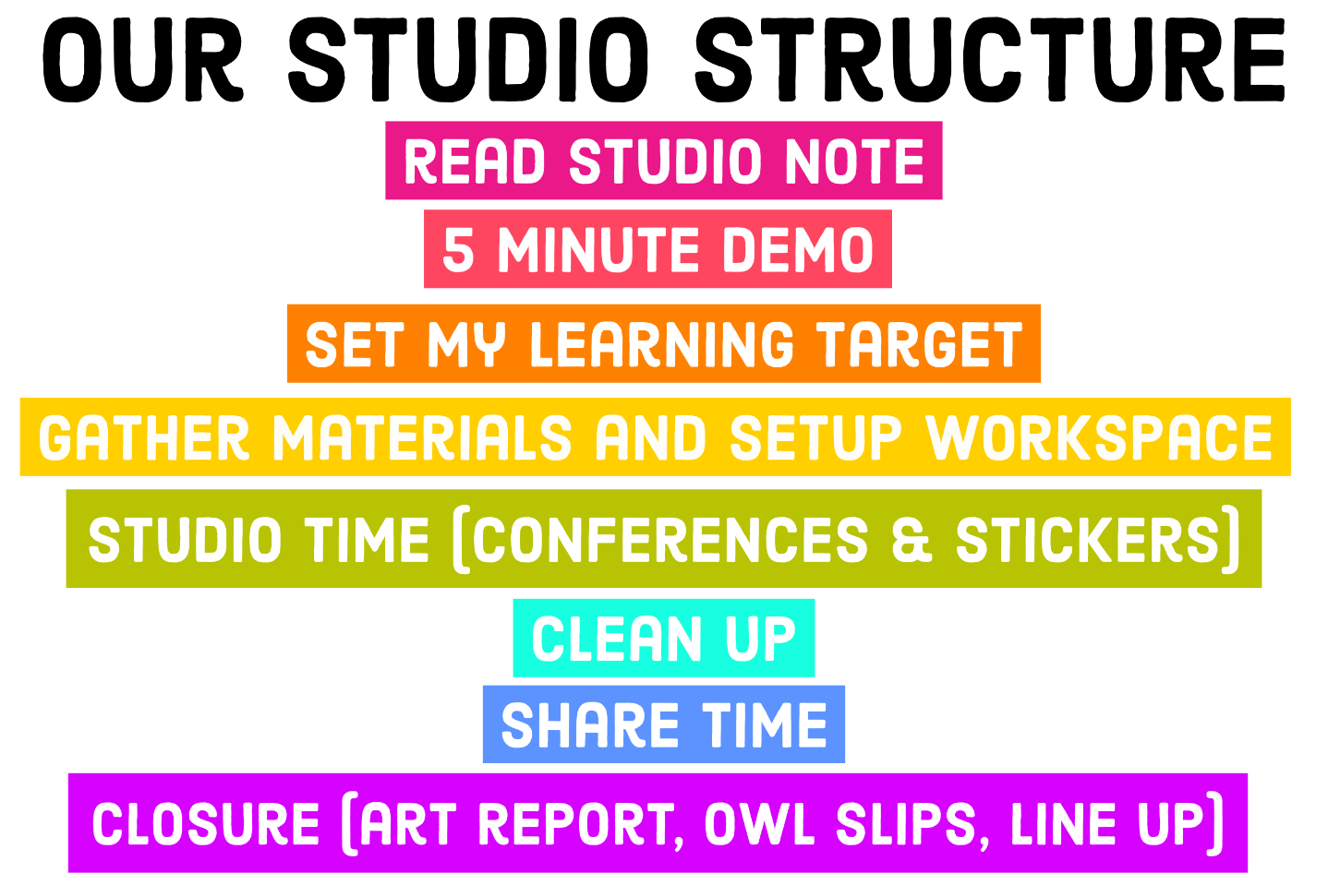

Engage Students in Healthy Relationships with Others: I see the art room as a place for students to work together as a collective of artists and I try to model this idea with my own behavior when I address students and when dealing with behavioral issues. In my high school experience, I tried to set the stage for a community of artists and learners by creating an icebreaker activity which encouraged students to forge connections by finding common interests and values with each other. The lesson started with students choosing a personally meaningful quote. They wrote these quotes then posted them on the board and were asked to choose another quote from the group that they found meaningful. Once they chose this quote, they were asked to visually interpret it with a work of art. During our reflection, students were asked to share out about their artistic choices then ask the student who wrote the quote to claim it. In this way students could relate individually with other artists in their class and see that as a group we have things in common under the surface.
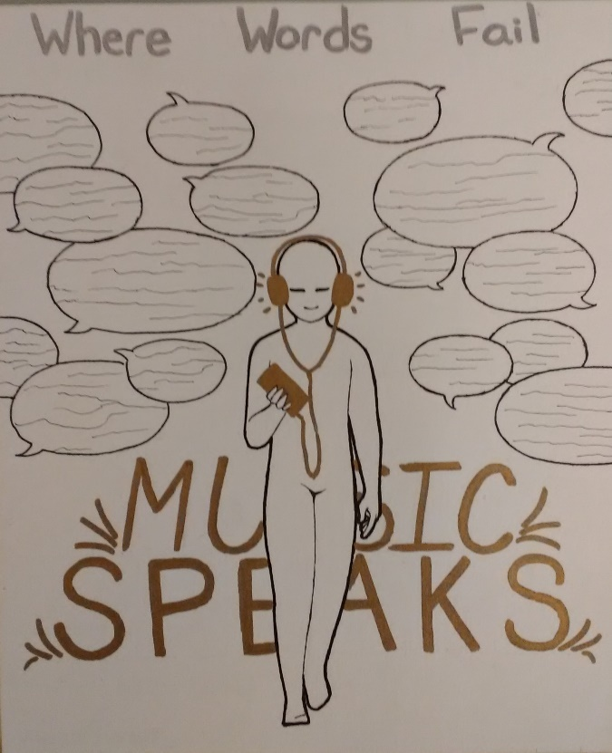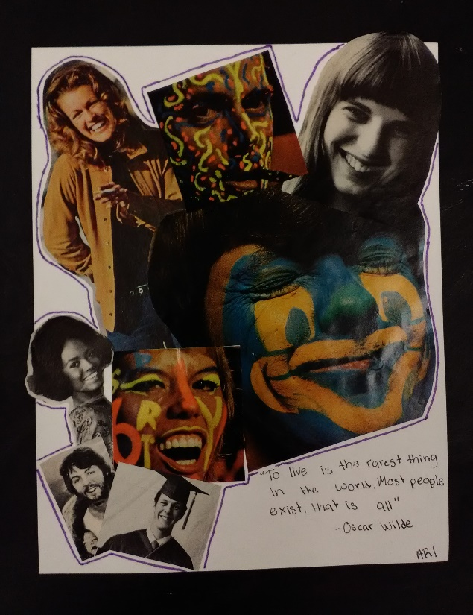

Quality Standard III: Teacher plans and delivers effective instruction and creates an environment that facilitates learning for their students.
Knowledge of Developmental Science: One of my biggest takeaways about the importance of developmental science in teaching is the understanding that all students begin in different places educationally and progress through their education at different rates. To plan effective instruction that enables all students to reach the learning targets of a lesson I not only incorporate accommodations and modifications for students with differing needs, but I try to plan every lesson with many different modes of access to the essential understandings. I think that it is important to model teaching after the way children experience the world which is through all their senses. Therefore, in lessons I try to incorporate opportunities for understanding through visual, tactile, written, and auditory venues. An example of this is in the Lorax lesson designed for second grade. For this lesson we first read “The Lorax” by Dr. Seuss and students were asked to participate in a group discussion about how the world was in the beginning, middle, and end of the story, which appealed to both auditory and visual learners. Next, they planned their artwork representing a world they cared about and a world they didn’t care for with a playsheet appealing to visual learners and artists who prefer to plan. They created their works of art then to reflect were asked to write how they used their hands, hearts, and minds and assess their attainment of the learning targets. Last, to appeal to auditory and group learners, students, shared with their partner, then with the class how they used their hands, hearts, and minds to create their artwork. Below are some of the learning aids used in this lesson:
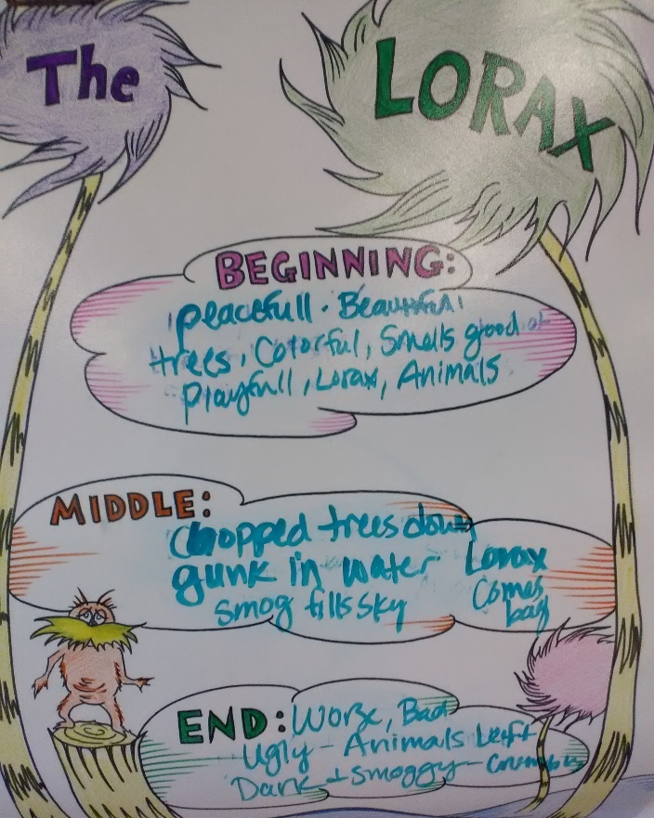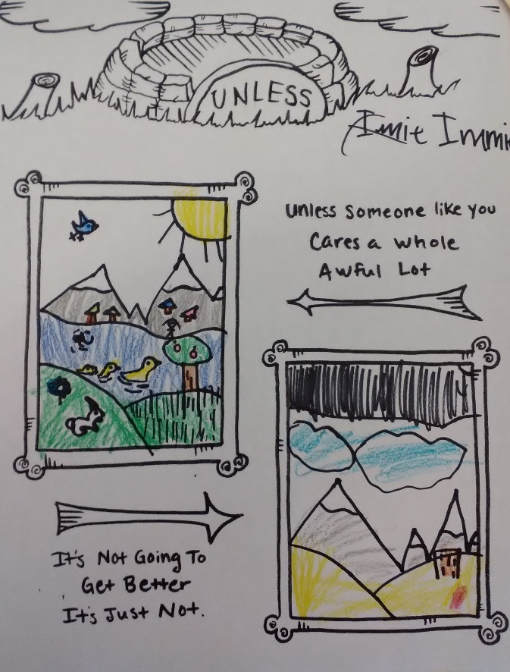
Uses Assessment to Provide Feedback and Inform Planning and Instruction:
I found that in high school I especially appreciated the opportunity provided by assessment to give students in-depth personal feed back about their work. Tracking the progress of about ninety students and checking in regularly to assess their development was difficult at times, but when I was able to sit down with a stack of assignments and rubrics and dive into their work it gave me an outlet to give them more individualized attention. Assessing their work also helped me gauge their level of understanding to inform the next lessons I taught. The example below is a rubric taken from the student-teacher interface “Bulb” for the student’s Reliquaries in Clay assignment. I divided my grading criteria into four sections including planning and ideation, application of media and language of art, communication and analysis (documentation on their digital portfolios) and studio habits. With each criterion bulleted I was able to check off and circle areas where students excelled and areas that could use improvement. At the elementary level, assessment involved more formative methods such as individual conferences with students where I track the areas they are excelling in and where they could use improvement.

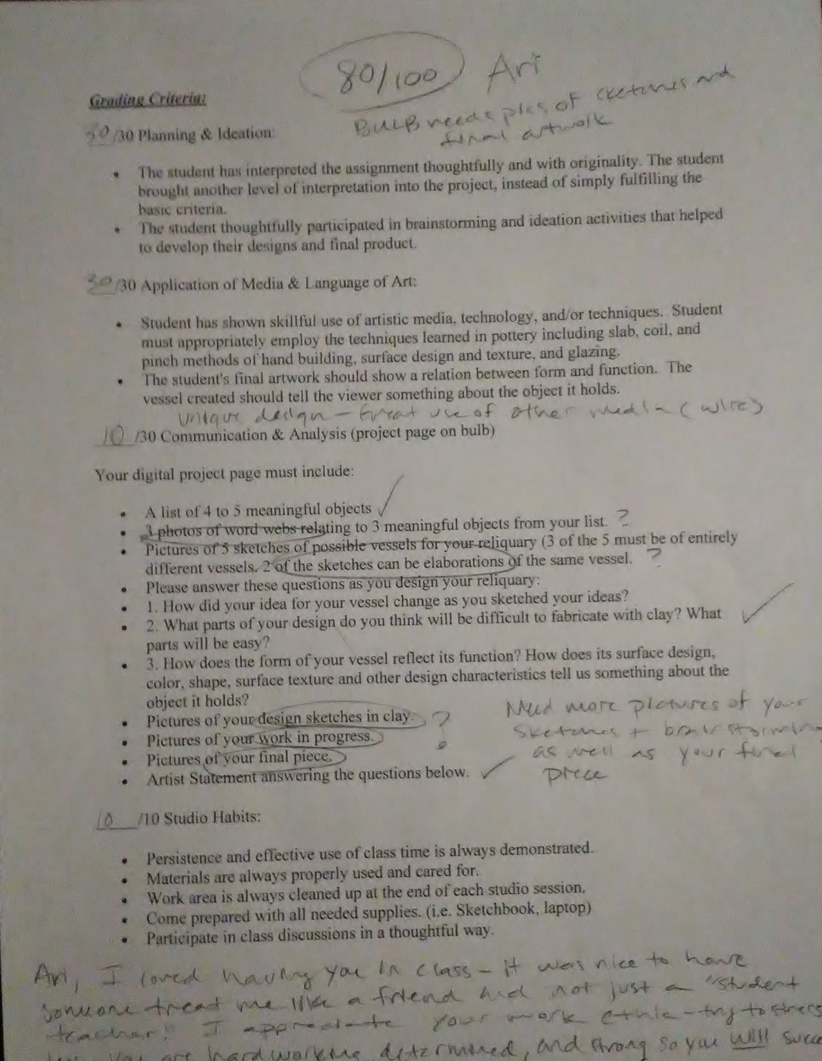

Integrates and Utilizes Technology: Technology, when used with purpose can be an essential tool to art education. It can serve as an interface between teachers and students, students and the community, and parents and teachers. In my experience at Rocky High School, technology was extremely important in communicating my expectations of students as well as providing students with any information or resources they needed to complete assignments. Students in pottery and jewelry were expected to document each of their works of art on their digital portfolio which was the interface I used to grade their work. They not only documented their final work, but their planning, ideation, research, sketches, artist statements, reflections, work in progress etc. In this way I was able to assess and evaluate their entire artistic process rather than just the final product. I also had my own online website within our class group where I could post the assignment requirements, pictures of contemporary work or examples, rubrics, and demo videos for students to access at any time. This technology also helped cut down on paper-waste because I didn’t have to print out ninety copies of every assignment sheet or rubric. In my elementary experience we use technology as a tool to create demonstration videos and to document student work on “Artsonia” as a part of the student’s digital portfolios. The demo videos have been extremely helpful because students very rarely interrupt them, and they ensure that every student gets the same information about a technique or tool (and they save me from doing the demo a million times!) Below is a link to my Rocky Mountain High School website:
https://www.bulbapp.com/katiewalker1990
Establishes High Expectations for Students:
My expectations for my students are focused around my view that when they enter the art classroom, they are artists and they are expected to think, act, and work as such. One of my goals as an educator has been to cultivate an environment where the kids aren’t students in an art class, they are artists in a studio which involves working like artists with their studio habits, taking care of their studios, and talking about their artwork using artistic language. In Mrs. King’s art classroom, I was fortunate enough to experience a teaching pedagogy that incorporates these ideals into the curriculum. TAB (Teaching for Artistic Behavior) involves giving the artists the tools, materials, and knowledge to work in various studios and then letting them make all the artistic choices in process and product. This means they come up with a concept or idea, choose the medium appropriate to express it, actualize their ideas while creatively solving problems, all with me as a facilitator. I expect students to take full responsibility for their personal artistic process, an idea that is sometimes new to them. The artists creating work are asked to reflect verbally on their work through conferences and share time where we discuss as a group how they are meeting the visual arts standards and utilizing studio habits. Below is the visual aid we use in Mrs. King’s class to talk about student art and to assess their attainment of the learning targets and standards:

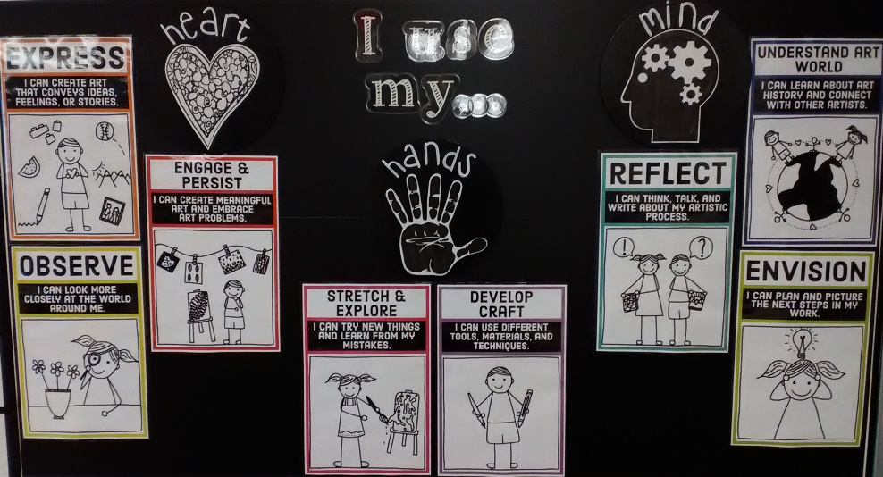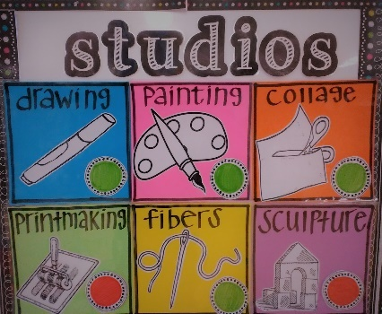
Provides Opportunities to Work in Teams and Develop Leadership Qualities:
Sketching and planning designs in my high school pottery and jewelry classes were essential to the artistic process. To ensure students were engaged in this process and to engage students in healthy artistic relationships with others I incorporated group or partner sketch collaborations into my instruction. This gave students an opportunity to work like artists by discussing their ideas and sketches with other artists and working towards solutions to artistic problems. I don’t have any examples of completed sketch collaboration forms, but the following are links to the documents used in these collaborations.
Sketch Collaboration exit ticket.docx
Communicates to Students Effectively:
In my classroom I value open communication between student and teacher. I try to always approach interactions with authenticity. To me this means being fully engaged in any interaction and making sure to give students specific feedback about their work rather than just saying something like, “that’s beautiful.” Rather I attempt to point out specific characteristics of their artwork that are successful or problems I saw them work through to encourage them to see that art isn’t always about being beautiful. I also value providing students with many different modes of communication that will enable students to reach learning targets. For example, we are currently opening the fibers studio in 3rd-5th grade. We do this by introducing a new technique and the tools required to complete it each class period. This week we introduced circle weaving and I noticed that even with the in-depth demo video students who tried the technique were still having trouble remembering and completing the steps. I ended up spending a lot of time helping individual students complete steps that the demonstration had just showed them. To encourage them to work more independently, I created circle-weaving menus which outlines the steps and tools needed to do this new technique and asked students to consult the menus or a friend before asking for my help. I saw that many students were eager to try the new technique and were more capable of working though their creative problems independently:
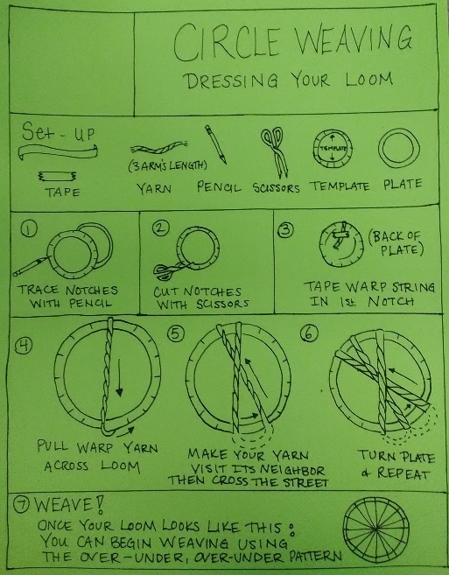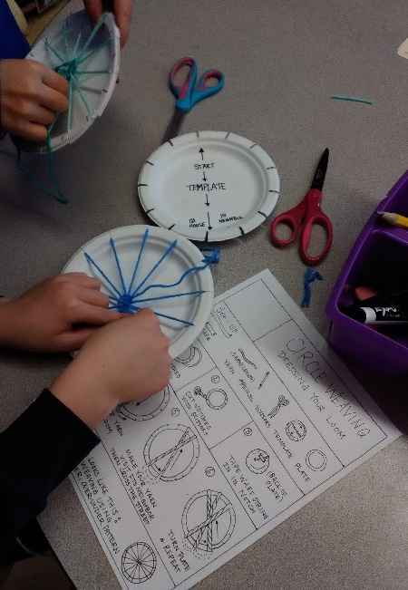
Quality Standard IV: Teachers demonstrate professionalism through ethical conduct, reflection, and leadership:
As a student teacher I have tried to present myself as a professional in all situations I encounter. I have seen that as an educator it is important to consistently reflect on my performance and adjust my practice. I feel that every day I learn something new about how to be a more efficient educator whether it’s how to communicate more effectively with my students, how to manage my classroom more efficiently, or how to improve my student’s learning.
Links Professional Growth to Goals:
I have had the opportunity as a student teacher to receive feedback consistently on my performance as an educator and I have tried to always adapt my practice to incorporate that feedback. I see my career as an educator as an opportunity to constantly learn and grow and I have been fortunate enough to have a mentor teacher that has supported me along the way. Mrs. King gives me consistent verbal feedback about my teaching and gives me written feedback daily about situations where I excelled and situations where I could use improvement. Because I respect her as an educator and admire her teaching style, I always incorporate her feedback into my practice in the future. In elementary classes I can teach the same lessons multiple times so I always reflect after each class on what worked and what could be improved and incorporate that into my next experience teaching that lesson. Below are examples of the written feedback I have received from Mrs. King:
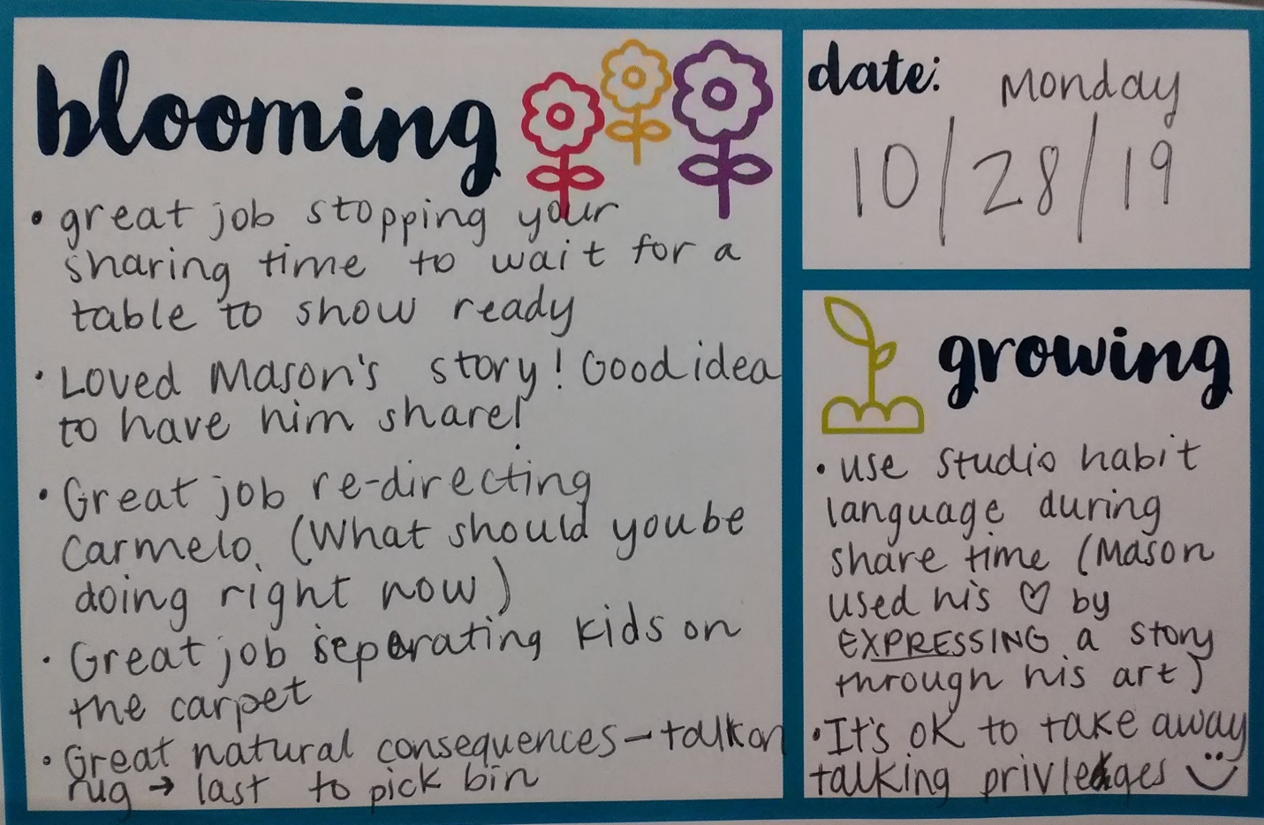
Respond to Complex and Dynamic Environment:
Flexibility is essential to any successful educator and I try to be comfortable with the ambiguity each day in the classroom presents. Hours go into planning a lesson, but the reality of teaching it often presents situations that I hadn’t accounted for, so I attempt to plan with flexibility and also be adaptable in the moment. In the Lorax lesson I taught this semester the second graders were asked to create two works of art that represented what the world would look like if they didn’t care and if they did which was meant to be focused on environmental change and transition. The lesson was meant to allow for a high level of student choice, but I didn’t account for one student’s choice to visually represent his uncle’s funeral. His uncle had passed the day before and he chose to paint the scene as the “If I don’t care” artwork. At first, I was wary to allow the student to make art about such a challenging situation, but after talking with him one on one we decided together that creating work about the event might help him work through some of the emotions he was feeling. The first drawing was dark and sad, while the second was colorful and full of flowers. I believe that working through his feelings by making art, enabled him to address some complex emotions that such a young person might not fully understand:
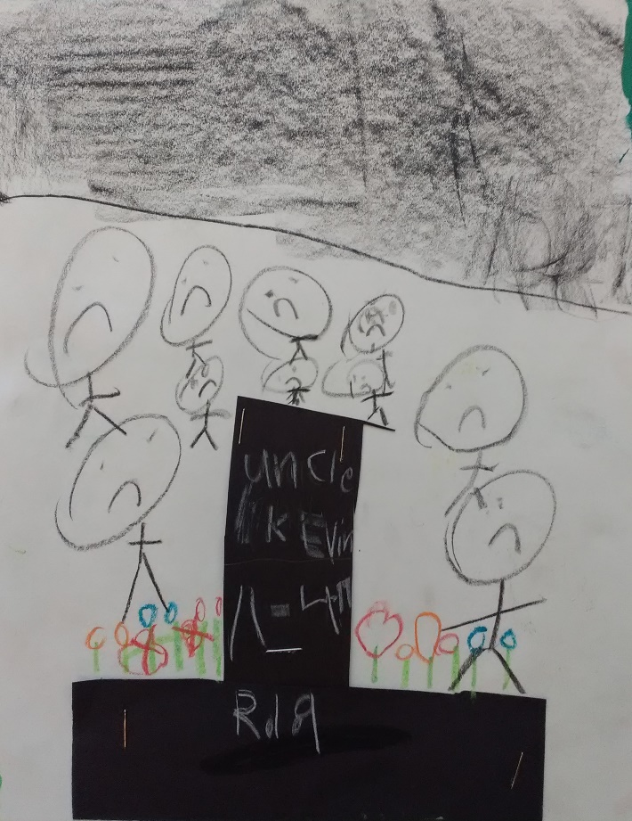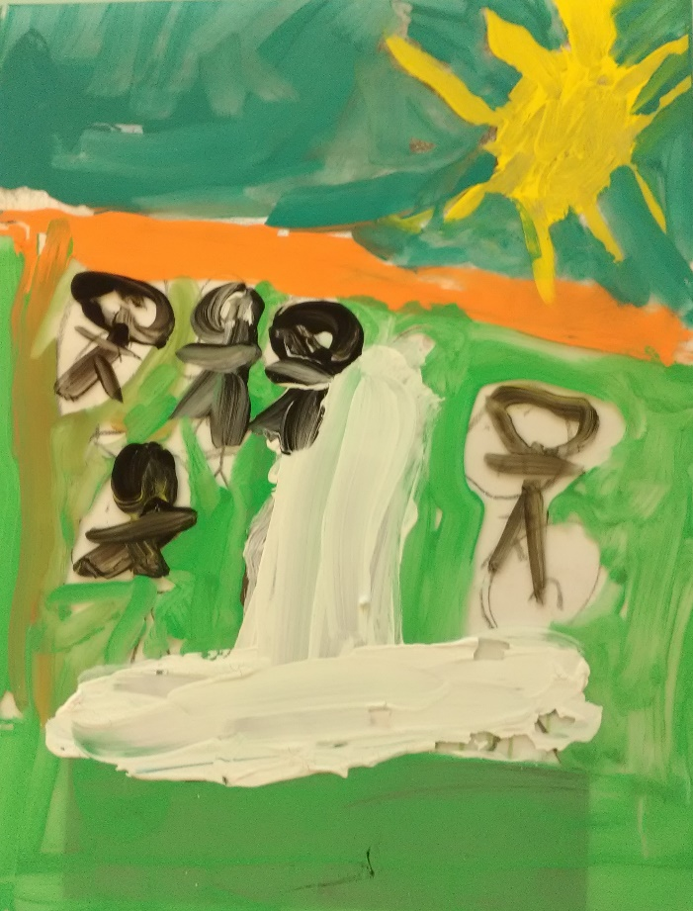

Promotes Professional Growth by Conducting Reflective Practices:
As part of student teaching, I was required to frequently reflect on my experiences through artistic creation. I truly valued this experience because it enabled me to continue my artistic practice and reflect in a way that produced a tangible object. By creating the artwork and a written reflection I was able to view my educational practice from a different perspective and work though emotions and problems in a thoughtful and meaningful way. Below is an example of one of the artworks I made in response to a prompt about time management and a section of my written response:
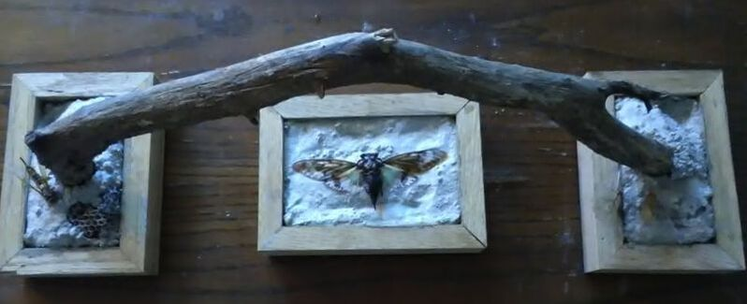
For this week's artwork I decided to work with concrete and natural found objects to create a piece that talks about the passing of time and the futility of trying to "manage it." Just kidding! When I look at the finished piece it seems to me that it comments on the ever-present passage of time and the natural modes of management which include decomposition and eventual death. I have used concrete to encase a number of biological objects which through the natural order of things have degraded, passed, and decomposed. Although in nature these objects would have decomposed until they became part of the Earth again, the concrete is acting to preserve them in time. To me this symbolizes the challenge of educators to attempt to manage time wisely. In the case of this artwork, the concrete represents the teacher's efforts, the decomposing objects represent the inevitable effects of the passage of time, and the work as a whole represents the beauty of the balance created by efficient time management.

Collaborates with Colleagues:
At O’dea Elementary School we have resources to help teachers in challenging situations. In the beginning of my experience I found it challenging to introduce routines to the kinder and first grade classes and get them to efficiently stick. For this reason, Rosalie and I enlisted the help of our TOSA (Teacher on Special Assignment) Laura Sutton to help us find some solutions. Laura observed the dynamics of these challenging classes for about a week then we met to discuss possible solutions. Most of our issues involved clean-up routines and Laura’s advice was to simplify the steps as much as possible and introduce them in a fun, somewhat “sing-song” manner. I simplified and it was effective, and I attempted the sing-song technique. While I continued to simplify instruction with these classes, the sing-song style just didn’t fit my teaching style, so while I tried it, I didn’t incorporate it in to my current practice. Below are my notes from our meetings:
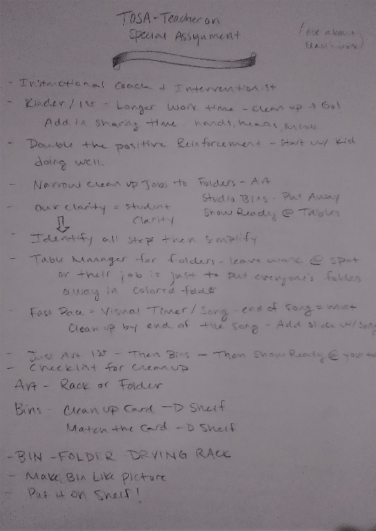

Demonstrates High Ethical Standards for Professional Conduct:
I had a particularly challenging situation with a student of mine in my high school teaching experience. He was late or absent most of the time and when he was in class he was on his phone, listening to music, completely unengaged. I tried every day to encourage him to get on task and work on his jewelry projects, but he simply wouldn’t, and I felt like I was hitting a wall with him. One day, I approached him to ask him to begin working and asked him to take out his ear buds and instead he turned up his music and completely ignored me. At the time I was infuriated. I started to feel like “who does this kid think he is? Why is it my responsibility to get him to be engaged? Its no skin off my nose if he doesn’t learn how to make jewelry!” and I decided to talk to him after class and tell him that, to me, respect is reciprocal. If I don’t receive it, I won’t give it back. That was the plan, but when I talked to him one on one, I had a change of heart and realized that his actions weren’t meant to hurt me. Rather than focus on his effort in class, I told him that if he ever needed to talk to someone, I would be there for him. I decided that respect should be reciprocal but in real life it isn’t always and the best way to encourage him to treat me with respect was to model that behavior myself. Although I felt like we reached a personal understanding, his work ethic in class didn’t improve much so I called home and I talked to his counselor about possible solutions. I wasn’t successful in reaching a parent, which upheld my belief that his home-life could be challenging, but his counselor and I worked out a plan with him to deal with future situations. The plan was that if I came over to him to ask him to engage in the class, he could give me a “5-minute” hand sign showing me that he needs five minutes to collect himself and get ready for the day. The agreement was that I would give him five, but by the end of those five minutes he would have to be ready to participate. Although he still didn’t excel in the class, I felt that he did put forth more effort. He worked sometimes in class and started coming in to work with me during lunches and after school which I looked at as a win. Overall, this experience taught me that it is my responsibility as his teacher to try to engage him and to assess his needs and try to accommodate them. As a teacher I find it is important to focus on the personal relationships you have with students as well as my responsibility to educate them.

